CREATING AND POPULATING TABLES
/* This script file creates the following tables: */
/* REGION, CUSTOMER, EMPLOYEE, SKILL */
/* and loads the default data rows */
BEGIN;
DROP TABLE IF EXISTS EmpSkill;
DROP TABLE IF EXISTS Employee;
DROP TABLE IF EXISTS Customer;
DROP TABLE IF EXISTS Skill;
DROP TABLE IF EXISTS Region;

/*Region Table*/
Create Table Region(
regionID int not null,
RegionName varchar(255)not null,
PRIMARY KEY (regionID)
);

/*Customer Table*/
Create Table Customer(
cusID int not null,
cusName varchar(35)not null,
cusPhone char(12),
regionID int not null,
PRIMARY KEY (cusID),
foreign key (regionID) references Region(regionID)
);

/*Skill Table*/
Create Table Skill(
skillID char(2) not null,
skillDescription varchar(255) not null,
skillrate int not null,
Primary Key (skillID)
);

/*Employee Table*/
Create Table Employee(
empID char(2) not null,
empLastName varchar(255)not null,
empFirstName varchar(255)not null,
empHireDate varchar(50)not null,
regionID int not null,
PRIMARY KEY (empID),
Foreign Key(regionID) references Region(regionID) ON DELETE CASCADE
);

/*Employee Skill Intermediate*/
Create Table EmpSkill(
empID char(2) not null,
skillID char(2) not null,
primary key (empID, skillID),
foreign key (empID) references employee (empID),
foreign key (skillID) references skill (skillID)
);

/*Region rows*/
INSERT INTO Region VALUES(1001, 'Northwest');
INSERT INTO Region VALUES(1002, 'Southwest');
INSERT INTO Region VALUES(1003, 'Northeast');
INSERT INTO Region VALUES(1004, 'Southeast');
INSERT INTO Region VALUES(1005, 'Central');

/*Customer rows*/
INSERT INTO Customer VALUES(1, 'Bellsouth','222-333-4571', 1003);
INSERT INTO Customer VALUES(2, 'Comcast','253-444-5555', 1003);
INSERT INTO Customer VALUES(3, 'Enron','367-555-6666', 1005);
INSERT INTO Customer VALUES(4, 'Exxon','444-777-7777', 1004);

/*Skill rows*/
INSERT INTO Skill VALUES('S1', 'Data Entry I',12);
INSERT INTO Skill VALUES('S2', 'Java I',25);
INSERT INTO Skill VALUES('S3', 'Python I',25);
INSERT INTO Skill VALUES('S4', 'Python II',35);

/*Employee rows*/
INSERT INTO Employee VALUES('E1', 'Daniel','Devaraj','2019-2-7', 1004);
INSERT INTO Employee VALUES('E2', 'Craig','Brett','2019-3-30', 1004);
INSERT INTO Employee VALUES('E3', 'Williams','Josh','1999-3-17', 1005);
INSERT INTO Employee VALUES('E4', 'Cope','Leslie','2017-4-21', 1002);
INSERT INTO Employee VALUES('E5', 'Mudd','Roger','2007-10-18', 1001);

/*Employee Skill Junction Table*/
INSERT INTO EmpSkill VALUES('E1','S1');
INSERT INTO EmpSkill VALUES('E2','S1');
INSERT INTO EmpSkill VALUES('E3','S2');
INSERT INTO EmpSkill VALUES('E3','S4');
INSERT INTO EmpSkill VALUES('E4','S3');

COMMIT;

TABLES
Customer Table
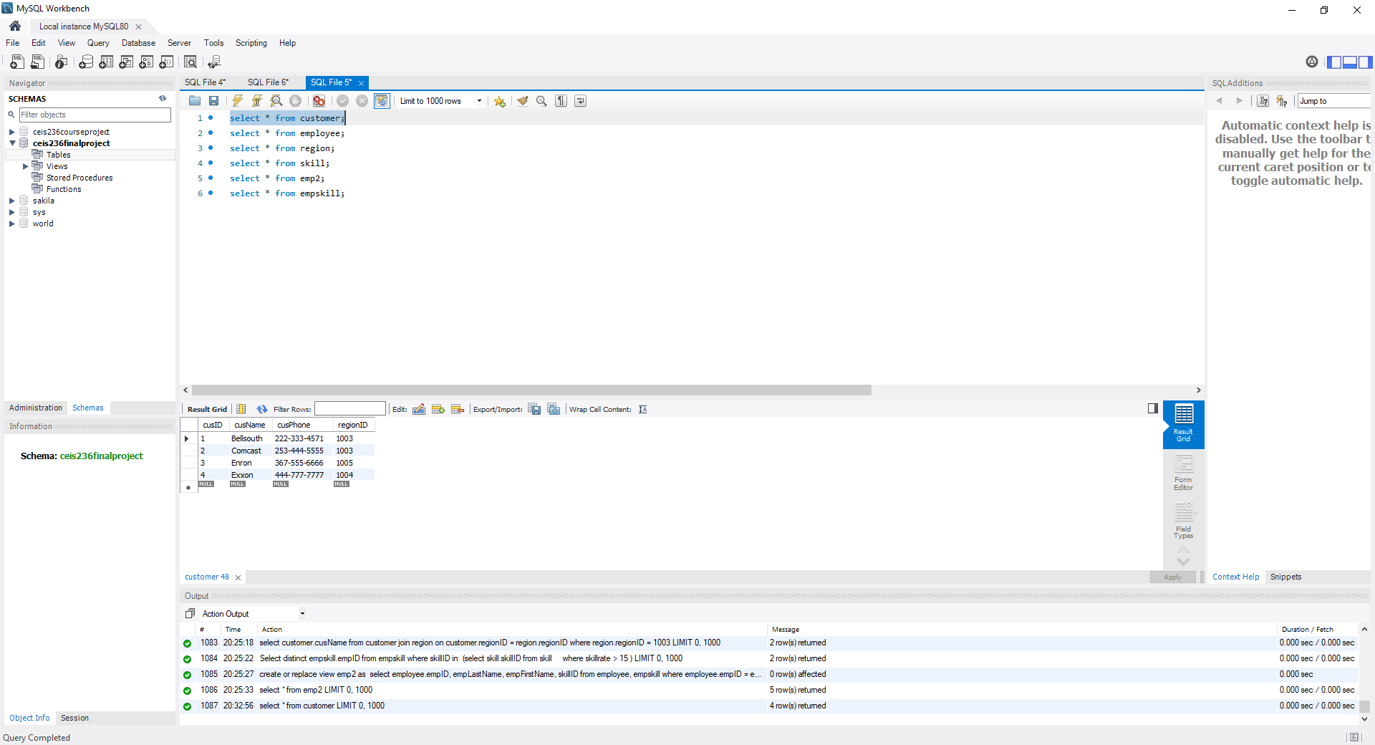
Employee Table
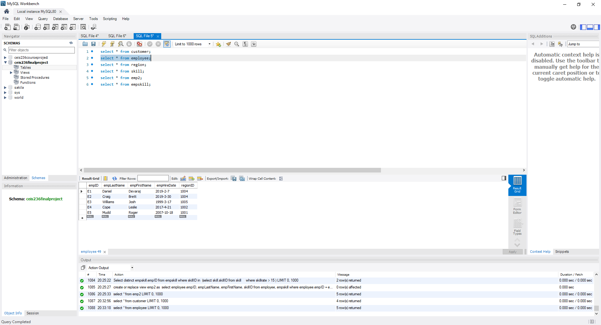
Region Table
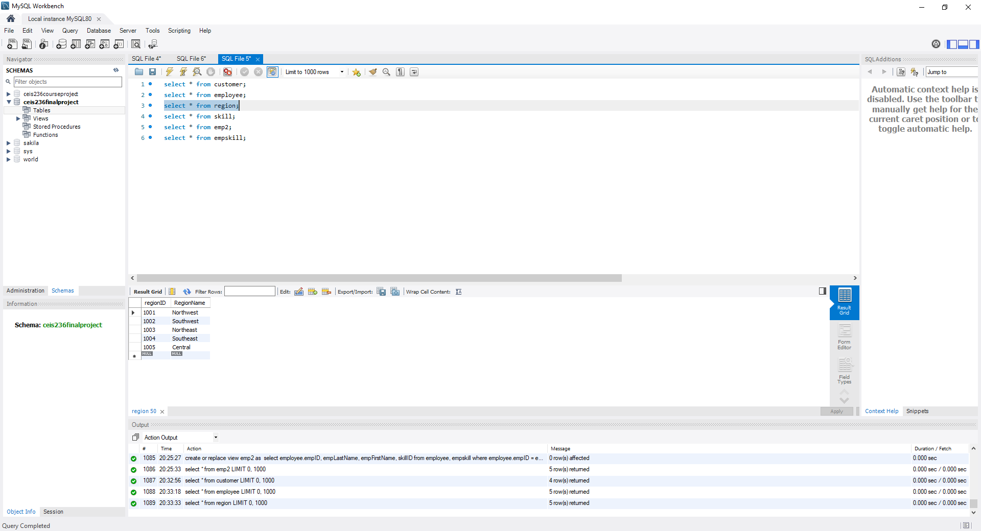
Skill Table
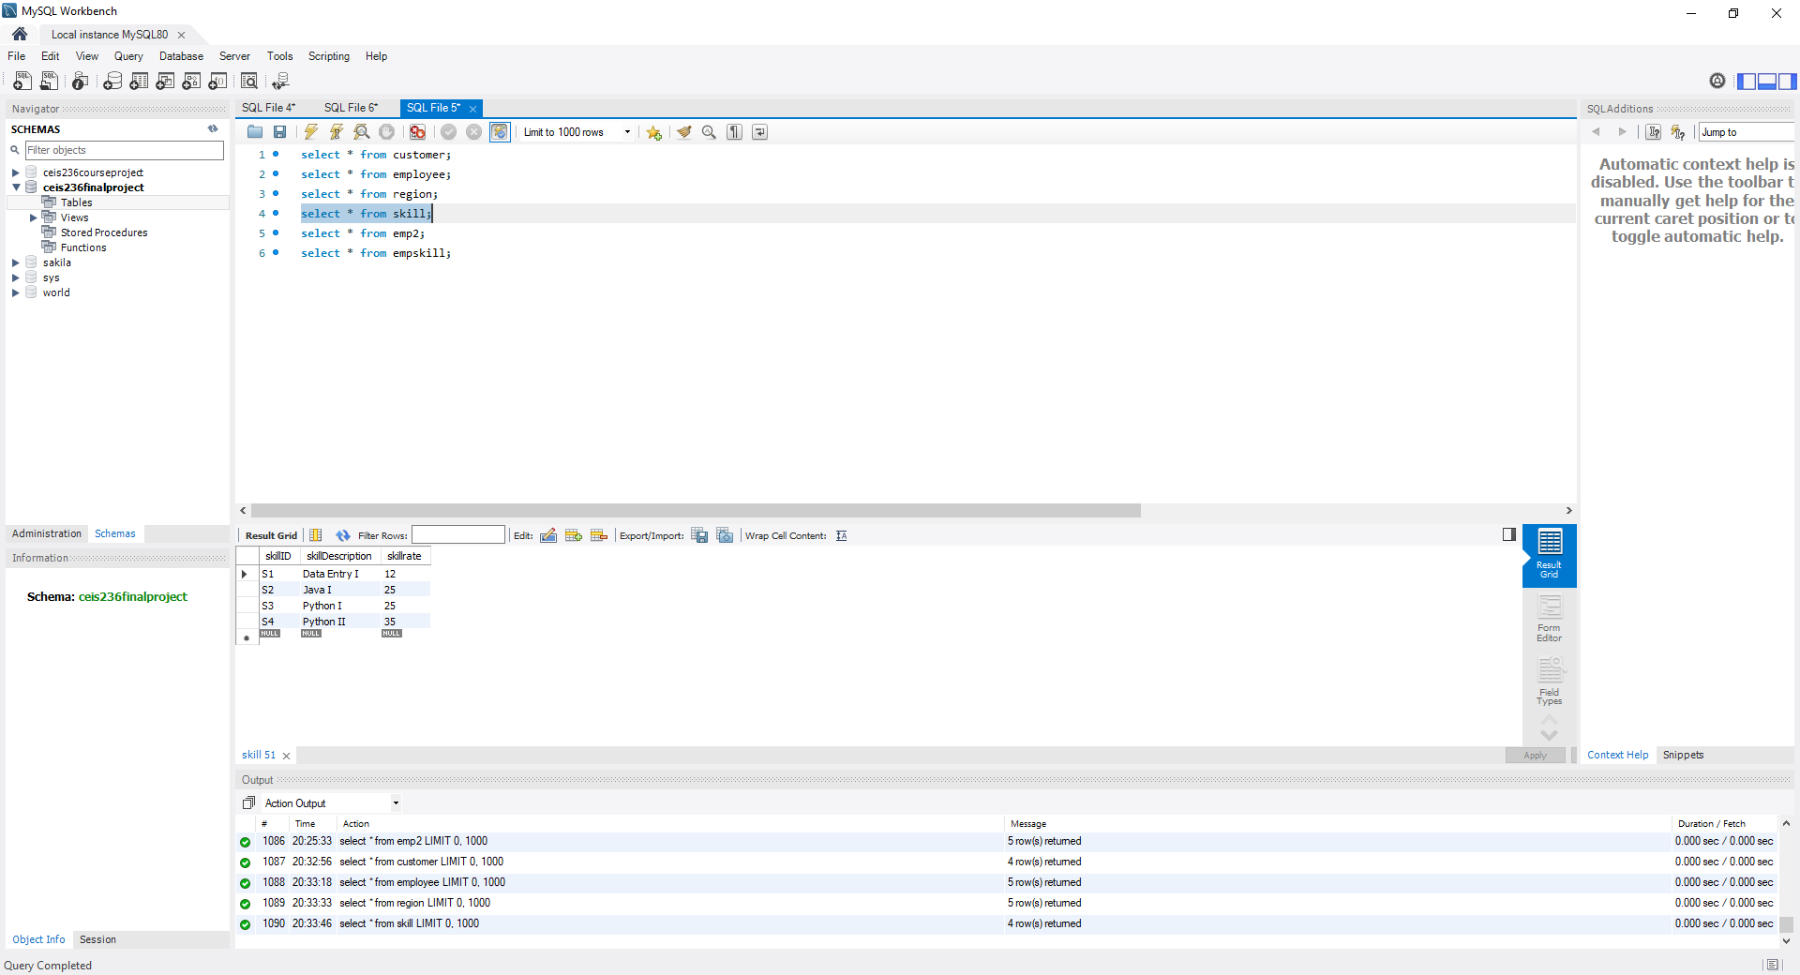

EmpSkill Intermediate Table
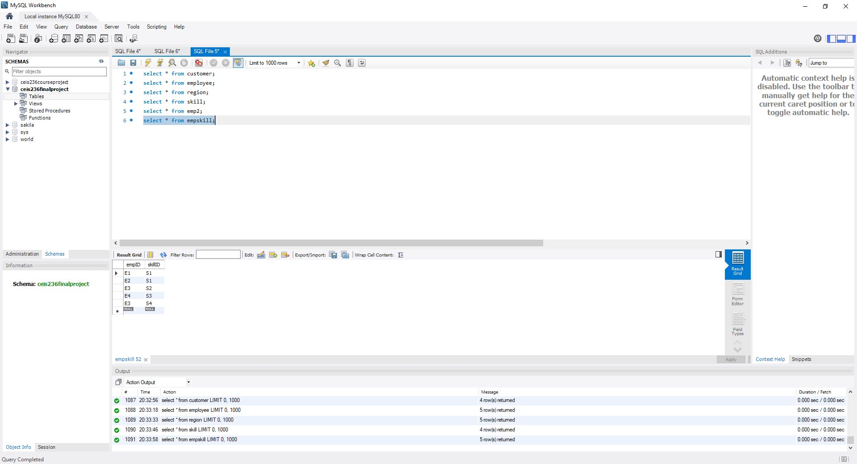

CODING FOR FOUR SQL QUERIES
/*Problem a*/
select round(avg(skillRate), 2) as 'Average', max(skillRate) as 'Maximum', min(skillRate) as 'Minimum'
from skill
;

/*Problem b*/
select customer.cusName
from customer
join region on customer.regionID = region.regionID
where region.regionID = 1003
;

/*Problem c*/
Select distinct empskill.empID
from empskill
where skillID in (select skill.skillID
from skill
where skillrate > 15
);

/*Problem d*/
create or replace view emp2 as
select employee.empID, empLastName, empFirstName, skillID
from employee, empskill
where employee.empID = empskill.empID
;
SCREENSHOTS OF PROBLEMS
A
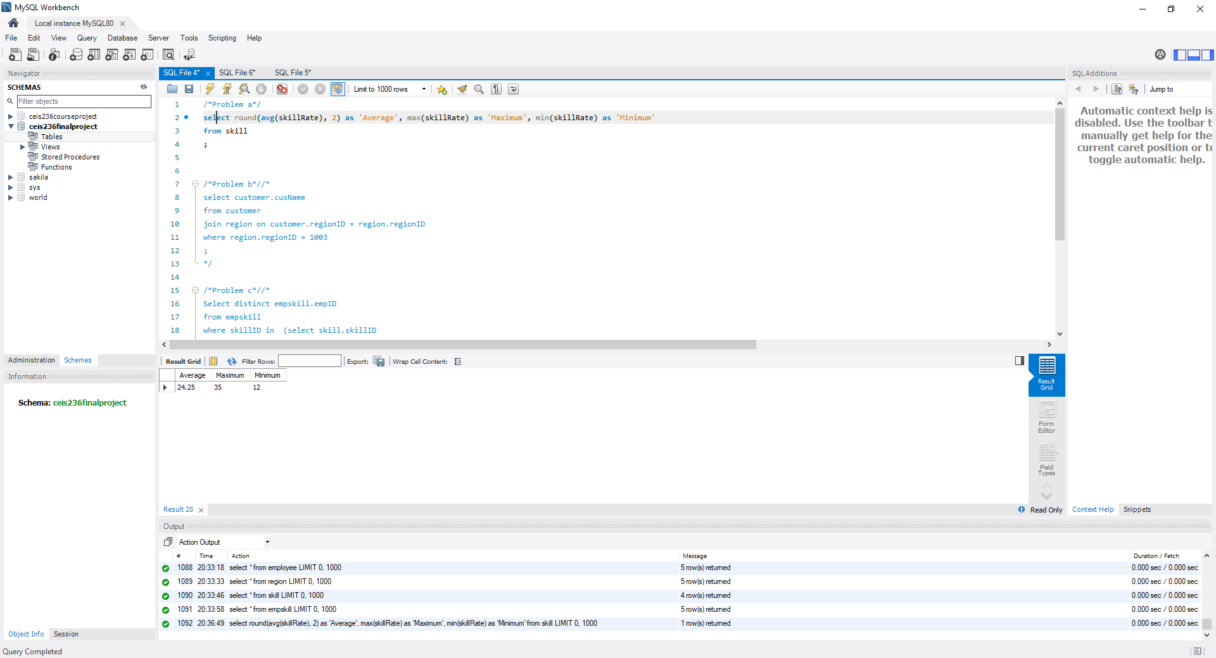
B
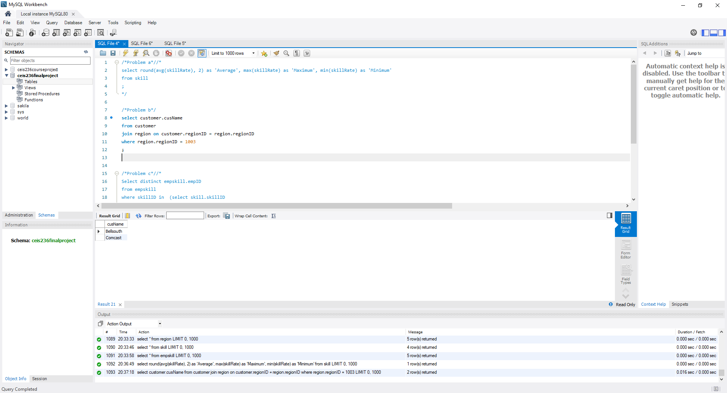

C
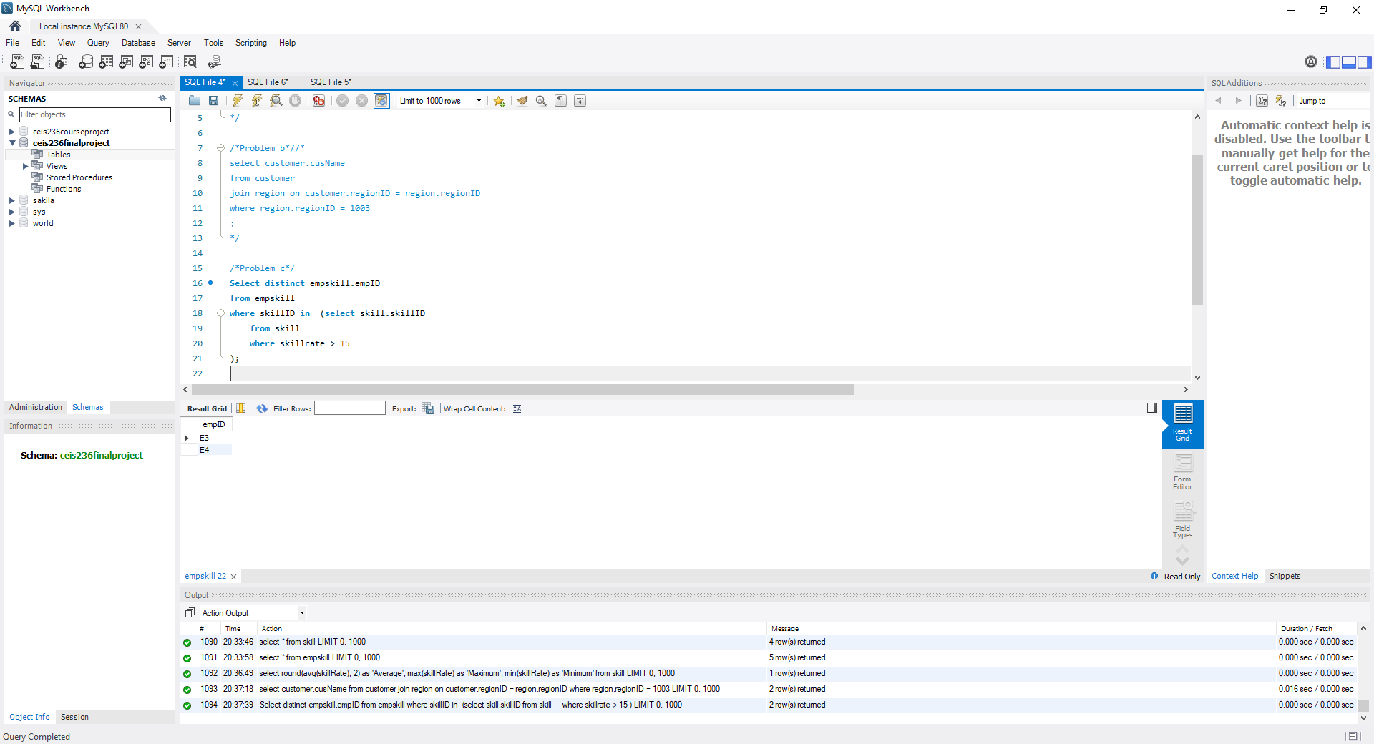
D
