Step 1 Classification
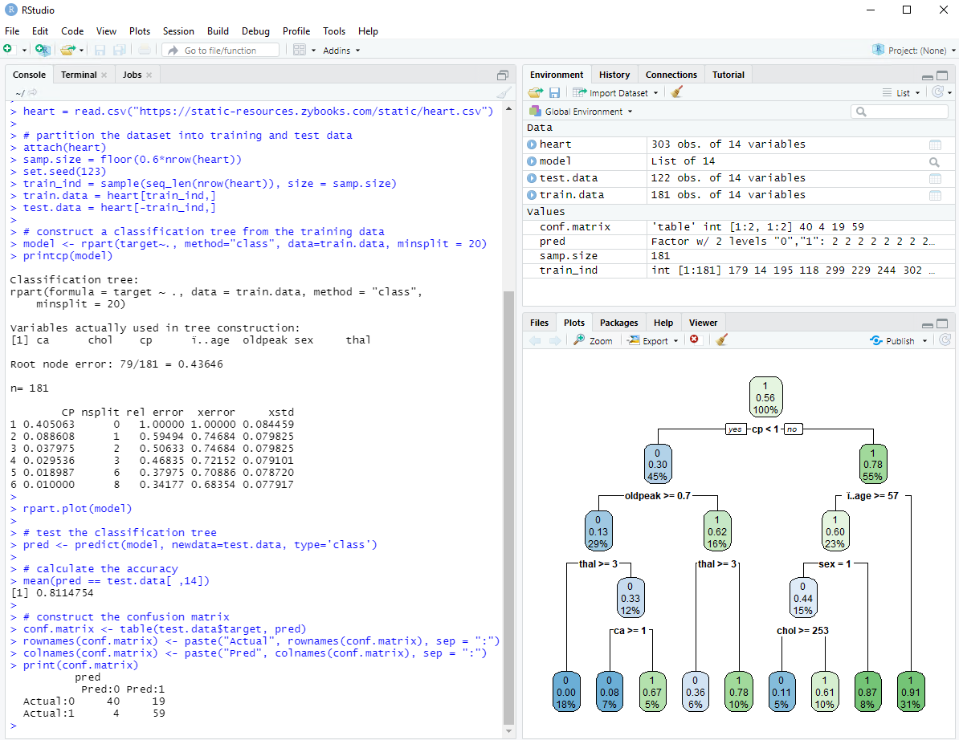

Step 1- Regression tree
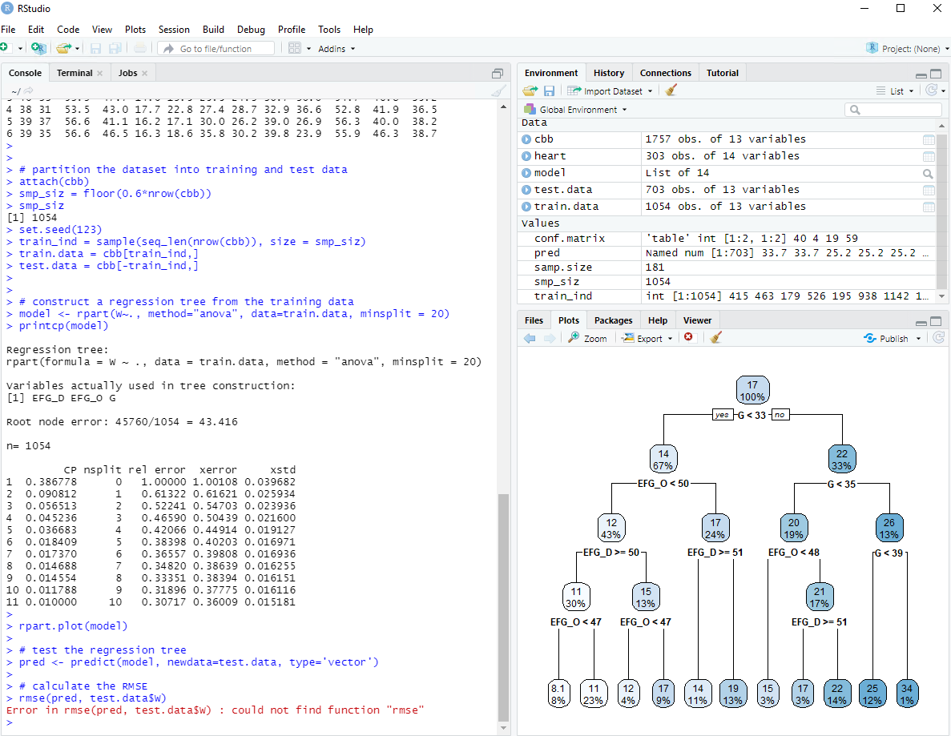

Precision tree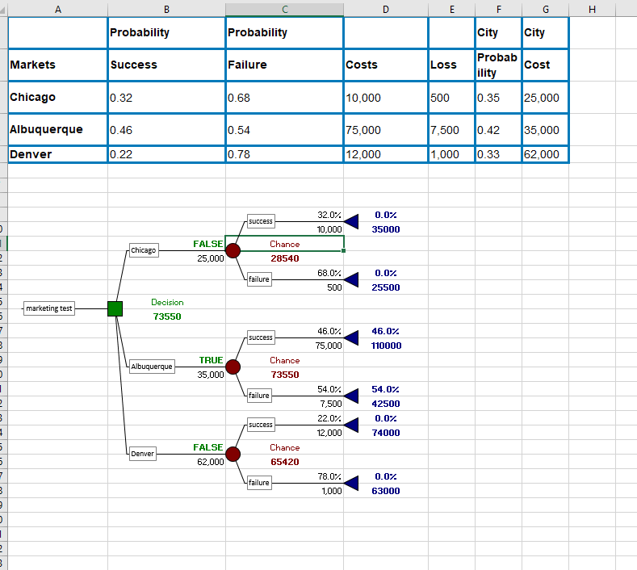
Report-
Using the two software’s for the case of charting, I would say palisade precision tree was much simpler to understand and use vs RSTUDIO. After making the two charts, it is easier to visually understand and put in information with precision tree vs RStudio. I will say however, if you are familiar with the syntax for Rstudio I believe you will be able to put in and manipulate information with the line commands. Both softwares are good to use. Rstudio is better if you know the syntax, excel with precision tree is better if you are first learning how to manipulate and input information because everything is visually done.

